NEWS RELEASE 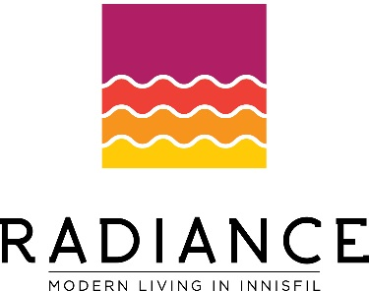

FIRST RELEASE SELLS QUICKLY
AT RADIANCE TOWNHOMES IN INNISFIL

INNISFIL, ON – November 27, 2017 - In just 10 days, the first release of RADIANCE contemporary urban townhomes in Innisfil has completely sold out.

This superb collection of bright and spacious modern designs by DIAM Developments is situated close to Lake Simcoe’s sparkling waterfront and minutes from an array of lifestyle amenities, just south of Barrie and within a one hour commute of the GTA.

New home buyers were drawn to the distinct modern architecture which envelops deluxe designs ranging from three- to five-bedrooms in sizes from 1,539 sq. ft. to 2,205 sq. ft. Open concept main living areas, large decks and optional rooftop Sunshine Terraces combined with innovative Flex Space on the ground floor make these townhomes truly shine!

RADIANCE boasts many fine interior finishes and high-quality materials, such as, engineered laminate flooring throughout main and second floors, tile flooring in kitchen, laundry, mudroom and bathrooms, natural oak hardwood stairs with custom railings, modern posts and pickets. Also included are 9-foot ceilings on main living and upper levels with large windows, elegant cabinetry throughout with quartz stone countertop in bathrooms. Deluxe master ensuite bathrooms have deep soaker tub and ceramic tiled shower with frameless enclosure. (All as per plan)

…more

-2-

RADIANCE is located less than 15 minutes’ drive to the South Barrie GO Station is also just 10 minutes from Highway 400 for travel north and south by car. The community is close to beautiful parks, schools, shops and restaurants, fitness and recreation, as well as Lake Simcoe’s attractive waterfront.

The second release of RADIANCE will be offered for sale in second quarter 2018, register today. The sales centre is now closed. RadianceInnisfil.ca

DIAM has established its reputation as a superior builder of luxury homes. The company’s goal is to bring the same quality to the condominium and townhome market. In the growing Town of Innisfil, DIAM has the perfect locale at RADIANCE.

-30-

EXTERIOR RENDERING
Cutline: RADIANCE will bring one-of-a-kind contemporary architecture to Innisfil. Illustrations are artist’s concept.

News Media Contacts:
tcgpr
David Eisenstadt/ Toni Pettit
deisenstadt@tcgpr.com / tpettit@tcgpr.com
416-696-9900 ext. 36 / 25

